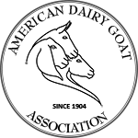
American Dairy Goat Association
ADGA registry, based on original import records, is your warranty of good breeding and worldwide acceptance.
PO Box 865, Spindale NC 28160
(828) 286-3801 | Fax (828) 287-0476 | support@adga.org | ADGA.org

Bill of Sale

THIS IS TO CERTIFY THAT I HAVE THIS DAY SOLD TO
Date of Sale

Purchaser ADGA ID #

PO Box or Street Address

City State Zip

Animal’s Name Date of Birth

Sire Registration #

Dam Registration #

Signature of Seller ADGA ID #

Complete Address

BOS20200512

